**CONCLUSIONS AND RECOMMENDATIONS**

After performing the requested executions, we had to make an analysis of the results.

One thing that should be taken into account by its great importance is that at the time of the executions a problem where the server rejects Pivotal Tracker showing many requests had the following error:

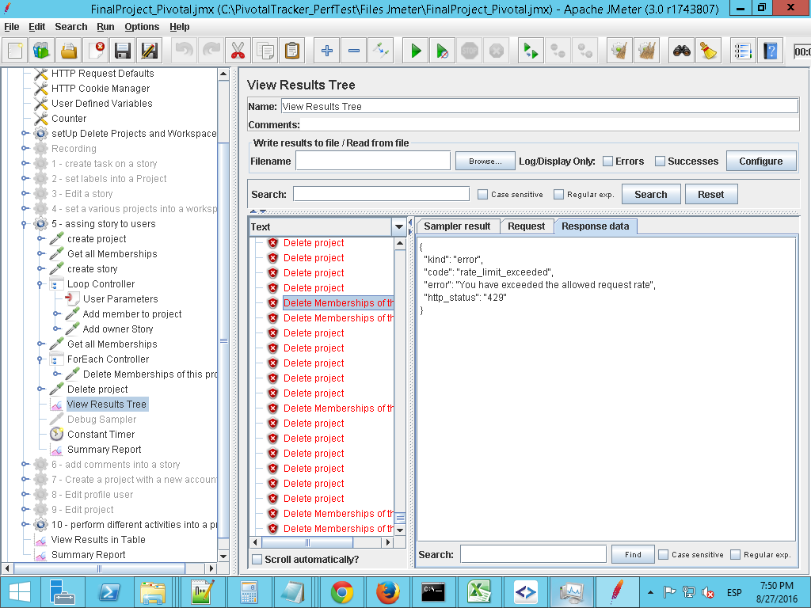

This is due to the large number of sent and applied in a short time requests.

**ANALYSIS OF RESULTS**

**Conclusion:** The graphic shows expected results, as the number of requests is rising according to increase of users

**Recommendations:** Non

**Conclusion:** Because the number of users, the response time is incremental. One result expected for this type of executions

**Recommendations:** Non

**Conclusion**: you can see a flow enters the first and second execution that the number of bytes received is incremental. One result expected for this type of executions

**Recommendations:** It is recommended to repeat executions with longer waiting times for other results.

**Conclusion**: The number of errors is low compared to other graphs. It is not normal that errors fall and rise so fast .

**Recommendations:** It is recommended that more executions to isolate the problem and get smaller amounts of errors.